Battle of the Neighborhoods

For a

Hungry Homesick Indian Soul

**Introduction**

There is no place like home and the time we miss home most is when we eat food. Our taste palettes crave for something they are used to eating on prolonged exposure to new things no matter how much we deny this fact.

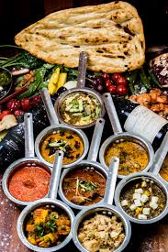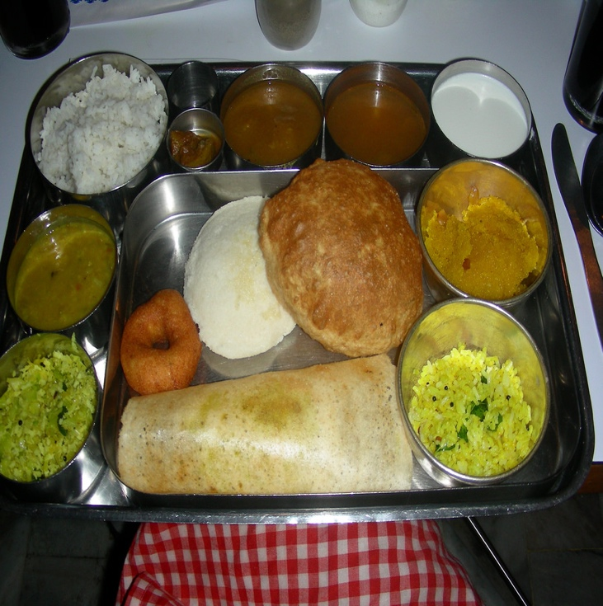

Food looking like this is exactly what every homesick Indian expat craves for.

**Business Purpose**

This project aims at helping an Indian Expat understand which neighbourhood is best suited for visiting when he is craving for Indian food and also shows the top 10 Indian Restaurants in the city.

The Project Analyses a few of the major cities in the world as an initial phase. The cities chose for this are:

1. Toronto, Canada

2. New York City, USA

**Data**

* A Foursquare account with valid Credentials
* Data for New York
  + Data as provided by Coursera in the IBM servers (<https://ibm.box.com/shared/static/fbpwbovar7lf8p5sgddm06cgipa2rxpe.json>)
  + This data is in json format
  + The data was converted to a pandas dataframe as the one shown below. It was observed that New York has 5 Neighborhoods and 306 boroughs



* + The Geopy Library was used to obtain the geographical coordinates of Newyork City
  + A map of New York was plotted to view the boroughs and neighborhoods using the Folium Library

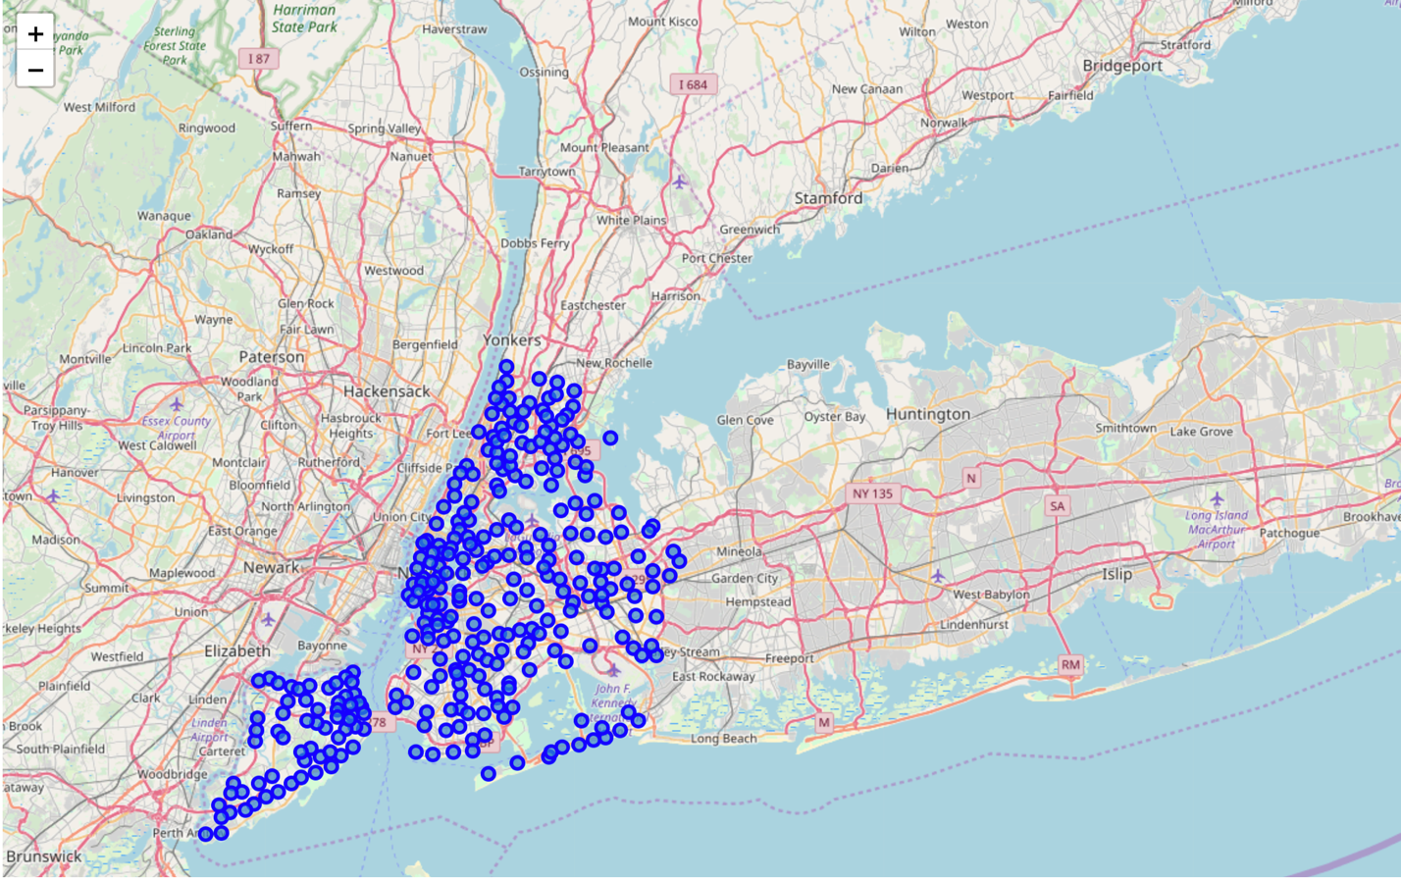

* + FourSquare API was used to query the Indian Restuarants (Limit =10) for upto 500m radius around each neighborhood

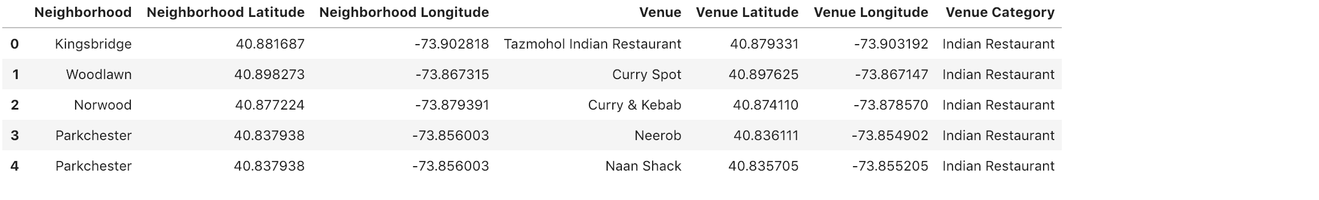

* Data for Toronto
  + Data about Toronto was fetched from Wikipedia (https://en.wikipedia.org/wiki/List_of_postal_codes_of_Canada:_M')
  + The table required was extracted from the wikipedia page, was wrangled and converted to a pandas dataframe using BeautifulSoup

The data under the same postal codes were grouped using Lambda functions.

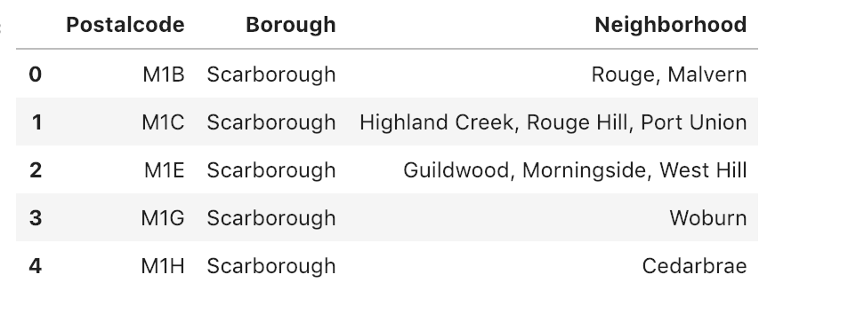

* + The Spatial Data provided by coursera was used to fetch the geographical coordinates for these locations and concatenated with the dataframe.

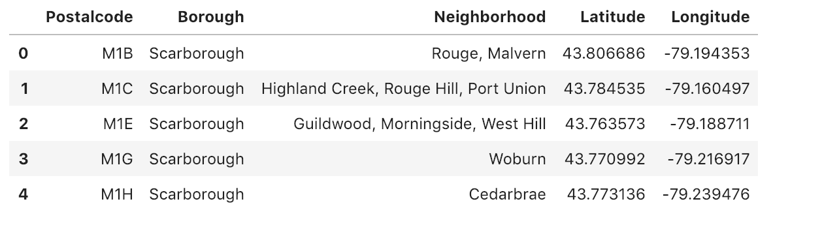

* + A map of Toronto was plotted to view the boroughs and neighborhoods using the Folium Library

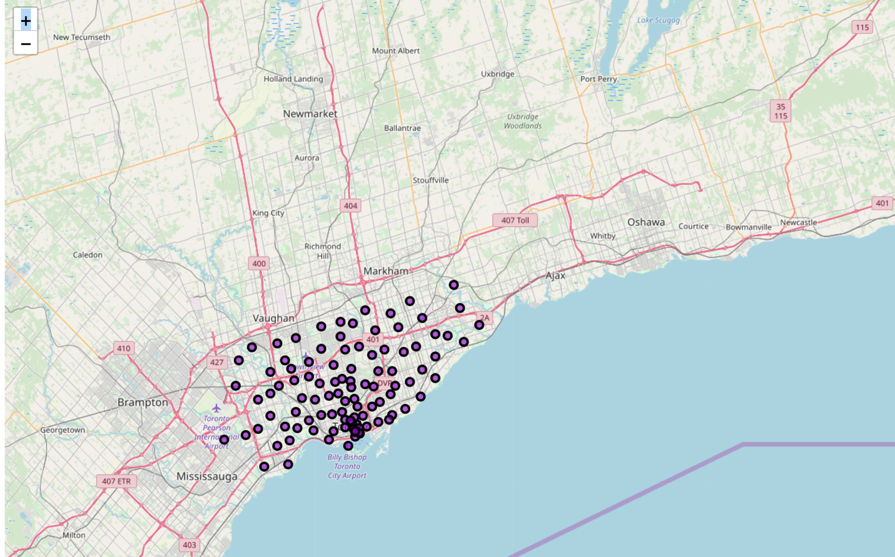

* + FourSquare API was used to query the Indian Restuarants (Limit =10) for upto 500m radius around each neighborhood

**Machine Learning**

**K-Means Clustering** was used to cluster the neighborhoods into 3 clusters for each city based on the data retrieved by querying for Indian Restuarants.

The K-Means Clustering was most appropriate in this scenario which required spatial analysis and unsupervised learning and was most accurate in segmenting the neighborhoods to clusters.

**New York Cluster**

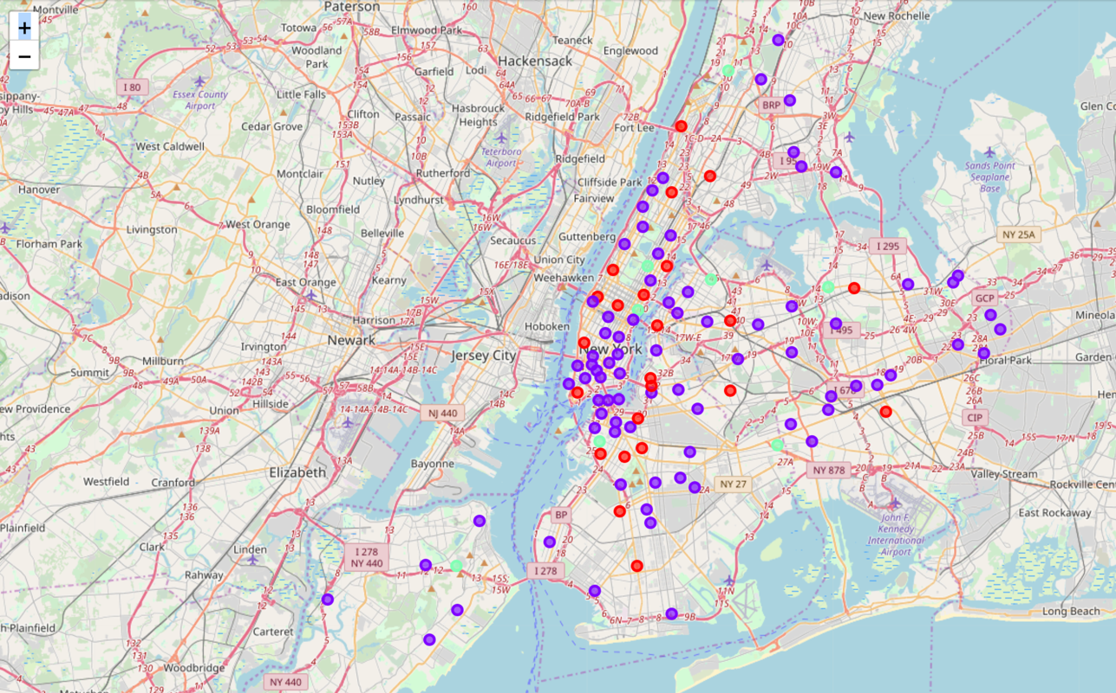

**Toronto Cluster**

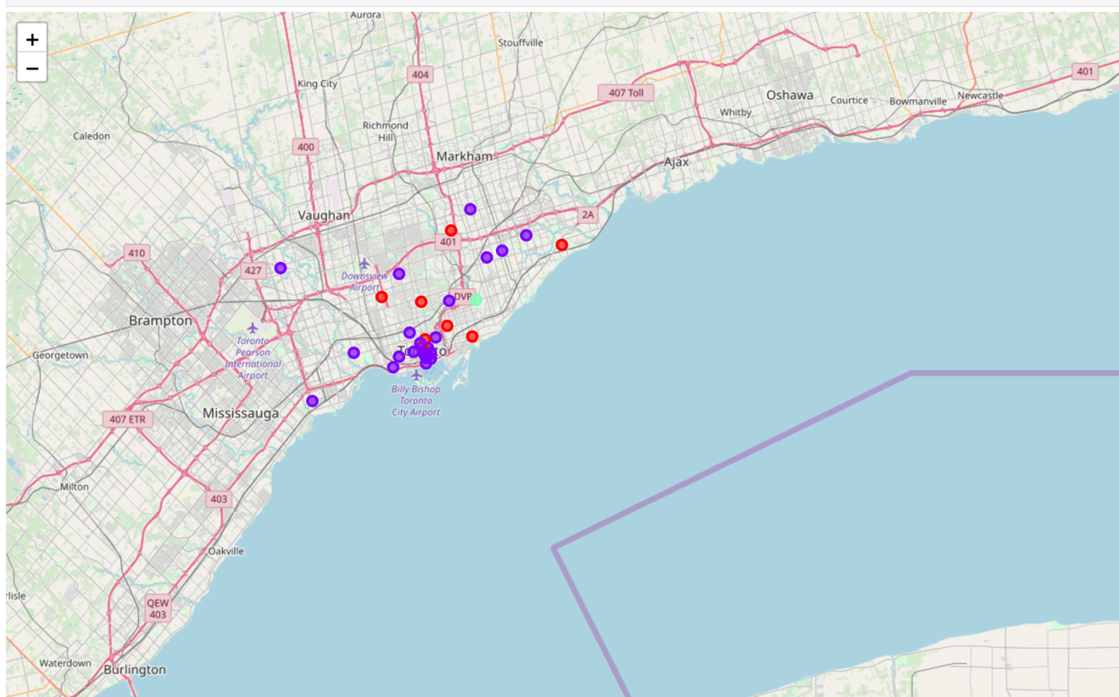

**ASSUMPTIONS AND CORRECTIONS**

The data obtained from FourSquare API and the data about the neighborhoods in each city weren’t having the same number of rows or had a different shape due to which I dropped rows which were not present in the data obtained from the FourSquare API for better results since these neighborhoods were the ones which dint return any Indian Restaurants.

**RESULTS AND OBSERVATIONS**

The **violet cluster** is both cases was chosen as the neighborhood cluster that an Hungry Homesick Indian Soul **Must Visit**

The **red cluster** is both cases was chosen as the neighborhood cluster that an Hungry Homesick Indian Soul **Can Visit**

The **green cluster** is both cases was chosen as the neighborhood cluster that an Hungry Homesick Indian Soul **Should Not Visit**

**Top 10 Indian Restaurants in NewYork**

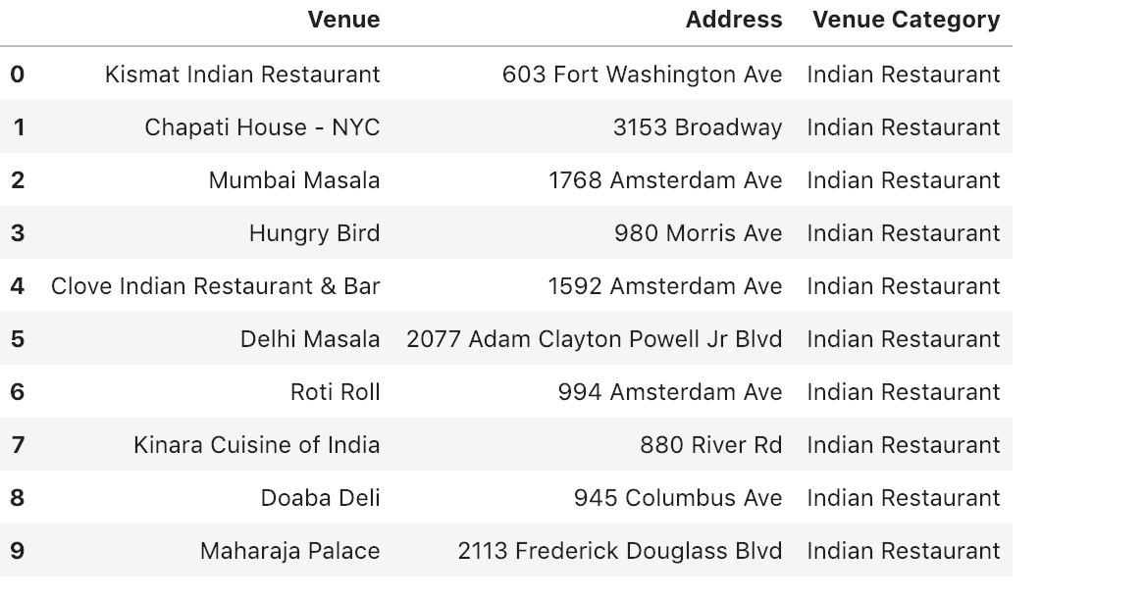

**Top 10 Indian Restaurants in Toronto**

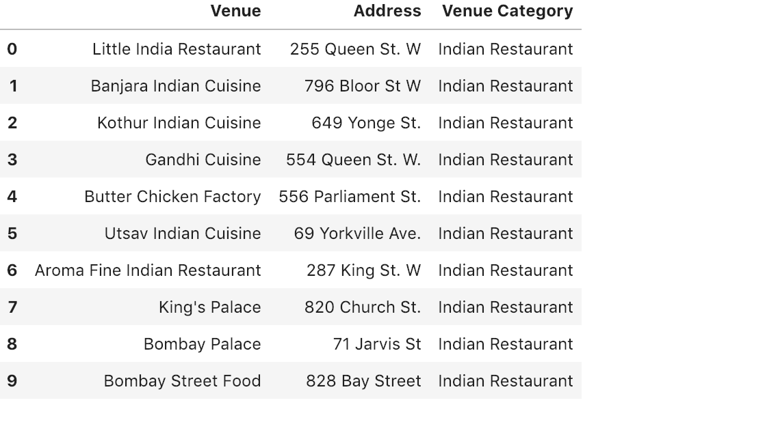

**Conclusion**

This project would help an Indian list out the neighborhoods they can visit based on the top 10 Trending Indian Restaurants in Toronto and New York City.

Happy Eating!